Congratulations on taking a step to learn a new hobby (sport) and social activity that will last a lifetime. Chess is a mental competitive game that has no boundaries or limitations. It can be played and enjoyed on various levels. Without proper guidance and instruction, “playing” the game can become overwhelming, intimidating and frustrating. Since it is a form of completion, you will not always win and must move forward to learn more or find opponents that are closer to your current level and experience. It is easy to learn the rules of chess and how the pieces move, yet it takes a lifetime to “master” the game and the interaction of the pieces. Chess requires practice and discipline to improve. You need to develop your skills gradually and learn topics, techniques and strategies to advance towards more complex games. Today, there are many on-line resources available for study and practice. Many players want to set up the board and start “playing”, but this is often frustrating and futile as moves are made with planning and purpose.
Setting Up The Board:
The first part of any game is learning the basic rules. There must be a place to start. Setting up the board correctly is the first important step.
Just think of the confusion in any game if the rules always changed from one time to the next.
Since the chess board is a square, you can turn it and face any direction and it will appear to be the same? Right?
WRONG! Even though you can set up the pieces and play the game, it will not be the same. It may appear to be the same, but it is not!
The first thing to learn about setting up the chess board is it is an (8 x 8) square
With alternating colored squares.

The “light” square goes on the right hand corner.
Light on the Right!

Some chess boards have letters (a – h) and numbers (1 – 8) around the edges.
If the board has these notation aids, the letter 'a' should be in the left (as WHITE is looking at the board). This is to help record or notate the moves of the game so it can be replayed and analyzed. This way, you do not have to remember everything. My teacher often used the famous for saying,
“The dullest pencil remembers more than the sharpest mind.”
Always be ready to write down things you have learned, or things you want to learn. Be open and receptive to new things. Listen to what is being said.
Every game of chess is a new opportunity. Past games and past performances have no impact on the current game that is about to be played.
We study and analyze games to improve and not make mistakes again!
Those who fail to study history are doomed to repeat it!
Start each day as a new game. Better yet, start each hour as a new game.
Don’t let the past choices ruin the present or the future!
Every square on the chess board can also be referenced by a name.
The "First Name" is a letter: a, b, c, d, e, f, g, or h.
These are also called 'Files' on the board. (Columns)
The "Last Name" is a number: 1, 2, 3, 4, 5, 6, 7, or 8.
These are also called the 'Ranks'. (Rows)
There are 64 squares on the board and they each square has a unique name.
In older chess books (prior to 1980), you will find another form of chess notation that was used to describe the pieces relative to each player and in reference to the King and Queen. This is called Descriptive Notation.

It Takes Time:
Learning to play chess is something that does not happen right away.
There is so much to learn you cannot learn it all at once.
Learning to play chess is also like learning a new language. You may be able to learn the words in the vocabulary and learn the rules for sentence structure and still not be able to speak the language very well. Even though we have learned how to spell, read, and write, this does not mean we will all become great authors.
It is also like math (which is like a language). You learn basic operations and then build and add onto those and develop a deeper and richer “vocabulary’ and understanding of how to use “tools” and operations and logic to solve the problems. You do not memorize how to solve math problems, you use basic fundamental knowledge and strategies to break a problem into smaller steps.
Everyone has different gifts, skills, abilities and talents.
You can try to learn chess from books on your own. You may have some success, but you often need a teacher and mentor to make the words come alive.
Tradition and Convention has chess boards drawn with White at the Bottom and moving up ↑the board and Black at the top and moving down ↓ the board.
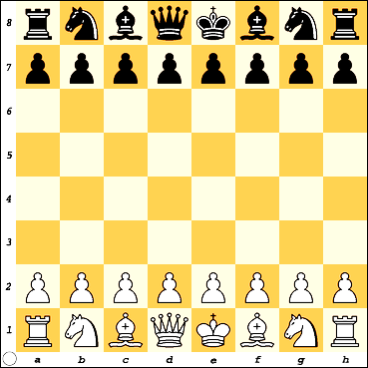
Anyone can play chess. The only thing you should look at is the board. The age, sex, race, grade or background of the players has no meaning. Some players have had more practice than others and some do seem to learn faster than others, but everyone can play. Learning a musical instrument, painting, cooking, or speaking another language are other skills you may learn, but some people will be better than others. We should help each other grow and learn something new each day.
We all seem to be born with same special talents and skills that make us unique.
But being different is what makes each person special!
Learn to play chess,
and you can find others all over the world to play with.

It Is Not a “Black” and “White” Thing:
The first thing many people notice is that the game is played with pieces of two different colors.
The light colored pieces are referred to as WHITE (light).
The dark colored pieces are referred to as BLACK (dark).
This should not be made into a grand issue of WHITE vs. BLACK.
The board and pieces could have been called anything:
Stripes and Dots, Silver and Gold, Sticks and Stones, Rocks and Shells.
The squares on the board are also called White (light) and Black (dark).
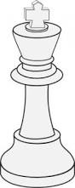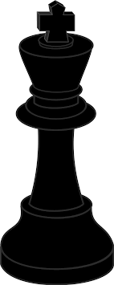
The Conflict:
Please understand that chess is not a fight between Black verses White; it is just a game where the two sides need to be distinguished.
On the chess board we need to identify our pieces and those of the opponent.
We have many opponents in life. Some of these are internal and some are external.
If you are like many new chess players, you want to jump in and start 'playing' a game of chess.
It is exciting you want to jump in, but you are not ready to handle all of the decisions that need to be made.
Chess is easy to learn but takes a lifetime to master!
There are not many rules in chess but there are some.
Every piece has special abilities and duties to do in the game. You must learn and master the power of each piece so you can use it appropriately to achieve your goals and objectives. Just as a baby learns to crawl before it can walk and walk before it can run, you must build up your understanding in order to become a better chess player.
Moves made without a plan, purpose or knowledge, are wasted effort.
Moving without a plan, is a plan to fail!

You have to know your purpose, set goals, make a plan and set a course and direction to reach it. Sometimes you will need to make adjustments and changes to the plan and sometimes you will have to make all new plans.
Some teachers of chess used to say “when it doubt, push a pawn”.
This can be some really bad advice! Since Pawns cannot move backward, their position and movement is extremely important. Advancing a pawn without having a plan is contrary to a good strategy. A pawn that is in the wrong place at the wrong time can actually turn into a weakness and be a hindrance to the development of your other pieces.
A quick game can be created using only the Pawns and a few rules how they move. Students should practice and master this game. I have seen many games where after many hours and moves, the only pieces left are the Pawns. (End Game).

