The KING is the most important piece in the game of chess!
The KING is never removed from the board.
Without a King, there can be no game!

Each side (or player) may have only one King.

in the game of chess, the King has very limited power.
A King must have the support of those under him.
You might want to think of yourself as the King or General on the chess board. Even though you are a very important person, you cannot do anything without all the pieces working together. You have a kingdom and an “army” to protect you, but you also have to go out and attack your opponent.
You have to balance your Offence and Defense to be successful.

The King is the tallest piece on the chess board
In the game of chess:
1) A King is never captured or removed from the board.
2) A King may only move one square at a time on any turn.
3) A King may move in any direction.
4) A King may capture pieces.
5) A King may never put himself in danger.
6) A King can never be next to another King.

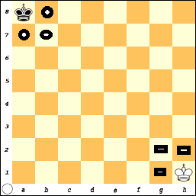
When a KING is in the corner he touches the fewest number of squares: Three (3).
From a8, the King covers: a7, b7 and b8.

When the King is on h1,
he covers: g1, g2 and h2.

What squares would the black King cover
if he was on h8?

What squares would the white King cover
if he was on a1?

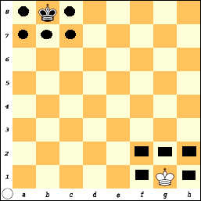
When the KING moves out of the corner to any other square around the edge of the board, he has the ability to reach five (5) squares.

What squares would the king cover if he was on a4?

What about if the King was on h6?

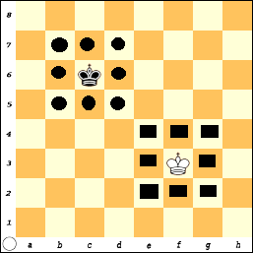
Finally, as the King moves away from the edge and into the center, he has the ability to reach eight (8) adjacent squares.

A King can be an important piece in the battle, and his ability to be effective (and cover more squares) increases as he moves away from the edge towards the center.

This does not mean that the King should always move into the center.
In some cases, it is better to leave the King protected in a corner.
When the King is in the center, he not only has the ability to attack adjacent squares, but he is also open to attack from eight directions.
The King is not just a passive piece in the game.
The King must be an active participant in the game, especially at the end.
The King has the ability to make decisions and get involved.
The Game-Of-Pawns (Add the Kings)
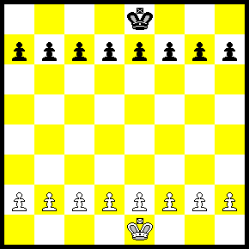 | The objective is still to get a Pawn across the board.  Remember:  The King is never removed from the board.  A King may only move 1 square in any direction.  A King may not place himself in danger  Pawns may not move backward.  Each Pawn may move 1 or 2 squares the first time it moves.  Pawns move forward but capture diagonally.

