The QUEEN may be the most powerful piece on the chess board (but that doesn't mean she is the most important). According to chess history, the Queen wasn't always as powerful as she is today. The Chess Queen was one of the weakest pieces on the board and could only move 1 square in any direction.
Now, the Queen is allowed to move as far as she wants. This change was thought to evolve around 1470-1480, with the rule of Queen Isabella.
However, just because you have power, you need to use it wisely.
To quote Spiderman, “With great power comes great responsibility!”

At the start of the game the Queen is near the King. When the game gets to the end, as powerful as she is, she (alone) cannot force checkmate on the other King; she needs the help of other pieces. In fact, one common position for checkmate is to have the King and Queen together again.

Because the Queen is so powerful, it makes sense your opponent will try to attack her. One common mistake many players make is to bring the Queen out too early. Since the Queen cannot do it all by herself, don't bring her out too early. She will be subject to attack and she can do very little by herself. If your opponent wastes time chasing your Queen around with annoying but meaningless threats, that too is wasteful. While there are some interesting traps that may work against weaker players, it is usually not ‘Good Chess” to bring the Queen out too early!

A Queen must be used with other pieces. A Queen should be wise and control her movement. Even though she is allowed to move all around, she doesn't have too. Now a Queen has a lot of power and can do a lot of things, but she starts the game next to the King and she usually needs to be near the King at the end of the game (if at the end of the game that is all there is left).

This diagram shows when a Queen is placed along any edge can cover 21 squares.
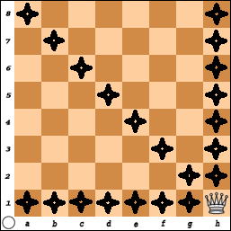
You should move the Queen to other squares around the edge.

Verify the Queen always covers 21 squares when she is on an edge.
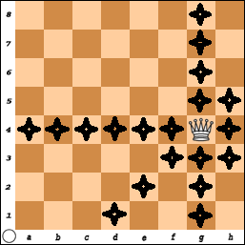
When the Queen is moved one square in from the edge she now covers 23 squares. Can you verify this?

Place the Queen on the 2nd or 7th RANK
or on the ‘b’ or ‘g’ FILE.

Count the number of squares the Queen covers when she is one square away from the edge. (There are 4 squares that were missed. What additional squares does the Queen Control? (f5, e6, d7, and c8)

How many squares does she cover when she is two squares in from an edge?
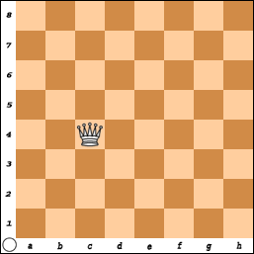
Place on Queen on Files: ‘c’ or ‘f’ or Ranks: 3 or 6.
Did you count 25 squares?
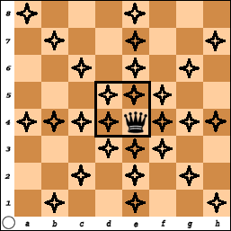
The Queen covers the most squares (27) when she is on one of the ‘center’ squares:
d5 | e5
d4 | e4

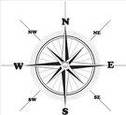
A student says she remembers how the Queen moves because if you look at the top of her crown, it looks like a compass with little marks pointing in 8 directions:
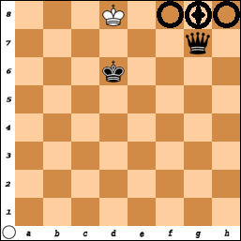
The very basic number of pieces to win is a King and Rook vs. a King.

Since a Queen can move like a Rook, it must therefore be possible to win with a Queen and King against a King

Your opponent's King cannot approach the Queen since the Queen also can move diagonally.

She also can make a box to limit the King.

However, you must not get careless and place your Queen near the opposing King.
While the King cannot place himself in danger,
if he (the King) is under attack,
he is allowed to capture the attacking piece and save himself.

To win the simplified game of a King vs. a King and Queen:
- The King must be against an edge.
- Your King must be in front of the King (1 square away).
- The final move places the Queen in the same rank or file as the King.

There is another square where the Queen can also move to checkmate White? Remember, in order to have checkmate, the King must be in check.

Try to find the answer before turning the page for the solution.
Did you see that Queen - D7 is checkmate #

Practice putting the Black King and the White King and Queen at various places on the board and work on this exercise until you can do it in 10 moves or less.
Practice... Practice.... Practice....
Once your game gets to this stage,
it should never take any more than 10 moves to finish the game!

Many new players hate this exercise. What I have often heard is "Why should I practice this? My games never get this far - I always get checkmated early."
Forcing checkmate means you have the ability to use your pieces together.
The whole purpose of chess is to checkmate your opponent.
All the moves at the beginning are just to get to the end.
The principle and the exercise is still important because it will help you learn how to use just two pieces as a team without being distracted by all the other pieces on the board.
If you can solve the easy problems then just maybe you'll be able to solve the problems when other pieces are in the way.

Do not get careless.
Even though the Queen is very powerful piece,
she may be captured if she makes a wrong move.

Black thought the game was over here.

The Checkmate that wasn't!
Black played his Queen to b8 and announced “Checkmate”. (It is Check – But is it over?)
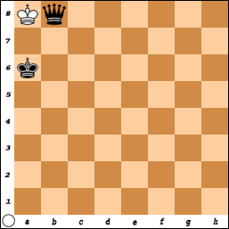
White knew she could not block or move her King but then she remembered –B.M.o.C.
Block, Move, or CAPTURE!

There is nothing to prevent White from capturing the Black Queen.

Kings are allowed to capture pieces. (K x Q)

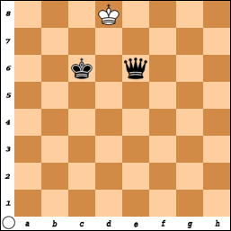
Since two Kings can never be beside each other, this game became a Draw or tie.
Stalemate, the win that got away!

It is easy to get a stalemate position with the Queen.

Practice setting up positions that are a stalemate.

Always make sure if the King is not in check, he has at least one square to move to.

If it is White to move,
this would be a stalemate. White has no legal move to make.

The Stalemate that wasn't!
In this example, Black became very happy. He knew he really should not win this game and White had just moved the Queen - e6.
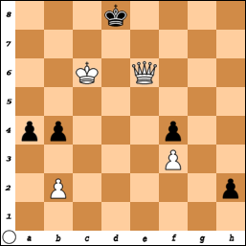
Black looked over the board and realized there was no legal move for his King and announced to his opponent the game was a stalemate and thus a draw.

The Black King is NOT in Check and there is no legal move the KING can make.

Just as they were about to shake hands, White remembered while there were no legal moves for the KING,

Black still had three possible other moves that could be made!
Pawn-a3, Pawn-b3 or Pawn-h1 (promotion)

Sometimes when you are playing and there does not seem to be any way to win, you move and give up pieces with the hope you are in a position to claim a stalemate. Some players when faced with defeat “resign” and give in.
When you resign, you are admitting defeat and are giving your opponent a victory. In every game, there is always a chance for a mistake to be made so make your opponent earn the victory.
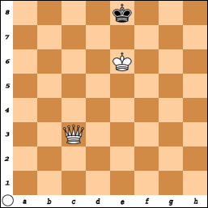  #1) White moves and wins with 1 move!  (and it can be done 2 ways) | 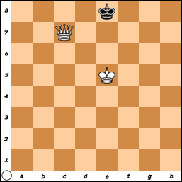  #2) White moves and wins in 2 moves.
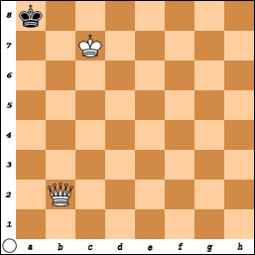  #3) White moves and wins in 1 move.  (and there are 5 ways to do it!) | 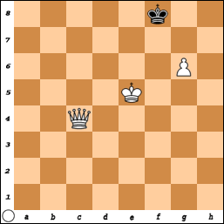  #4) White wins and can do it with 1 move!
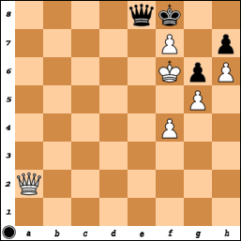  #5) Black has a real problem  but there is a saving move. | 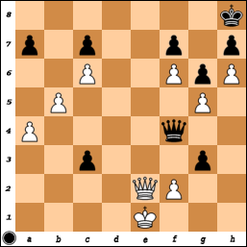  #6) White would win with Queen-d8,  but it is Blacks move!  What is a good option to play?
Answers to Queen Puzzles

#1 Since the King is along an edge and the Kings are facing each other, Queen to C8 is checkmate. (Q-h8 is also a checkmate).

#2 The Black King is ‘fenced in’ along the back row and can only move to f8. So, White can either move King to e6 or f6.
Black must move to f8 and then White moves Queen to e7 Mate.
(If white plays King-e6, King-f8, then, Queen-c8 is also checkmate)

#3 There are five ways that White can win.
Queen moves to: b7, b8, a1, a2, a3

#4 White could work on making the ‘fence’ with Queen-c7 and then moving the King around and getting checkmate.
But, Queen to f7 is checkmate since the Pawn protects the Queen.

#5 Black is in a lot of trouble here but she does have a clever move!
Queen- e6 Check.
If either the King or the Queen captures the Queen, the game is a stalemate. (but White must get out of check).
A better move is Q-e7 Mate.

#6 White can win the game with Queen - e8 checkmate, but it is Black’s turn.

Two possible options are: Queen – d2 Check or Queen x P-f2. After the exchange of the Queens, Black has a pawn and the King is too far away to it from advancing.
Q-C1 + would also force an exchange of the Queens.

