So far, you have learned how to:
1) Set up the board: (Light on the Right, a1 in White’s Left, Queen on her own color.)
2) How the Pawns move (Forward and capture diagonally).
3) How the King moves: (1 square in any direction).
4) How the game ends: checkmate, stalemate, and draw.
5) How to get out of danger: B-M-o-C: Block, Move, or Capture.
6) The basic movement of the other pieces.

At the beginning of the game, each player has two Rooks (one in each corner).
White Rooks are on: a1 and h1 Black Rooks are on: a8 and h8

The Rooks are sometimes called CASTLES. (But, you really want to call them Rooks).
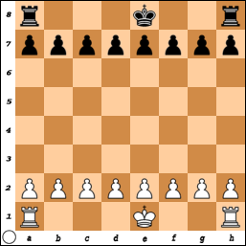
Rooks have a very interesting trait.
No matter where a Rook is placed,
it always covers 14 squares.

Other pieces get stronger as they move toward the center of the board and weaker as they move toward the edges, but the Rook has constant and unchanging strength.

Remember the King went from
3 squares in the corner
to 5 squares on and edge and
to 8 squares as it moved towards the center.

The Queen could cover 21 squares on the edge,
23 squares when moved 1 square in,
25 when moved 2 squares in,
and 27 when in the center of the board.
How the Rooks Move:

UP ↑or DOWN ↓ - Vertically in the columns or “Files”.
LEFT ←or RIGHT →- Horizontally in the rows or “Ranks”.
The Rooks move in a straight line.
They cannot change direction during a move.
They can move forward or backward.
They cannot go through or jump over other pieces.

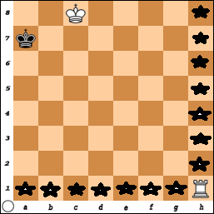
In this diagram, the Rook on h1 may move to:
Files: a1, b1, c1, d1, e1, f1, g1,
Ranks: h2, h3, h4, h5, h6, h7 or h8.

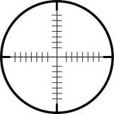
One student said she remembers how the Rook moves because if you look at the top of it, the little cuts go left and right and up and down like the cross on a target.

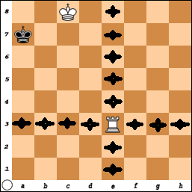

In this diagram the Rook on e3 also covers 14 squares.
It may move horizontally in the 3rd Rank to:
a3, b3, c3, d3, f3, g3, or h3.

It could move vertically in the e File to:
e1, e2, e4, e5, e6, e7, or e8.

PLACE THE ROOK ANYWHER ON THE BOARD
AND DISCOVER
IT ALWAYS COVERS 14 SQUARES!

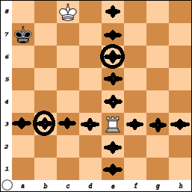
Making the Box: Fence in the King
One of the most basic principles in chess is how to win the game with just a few pieces.

Winning with a Rook requires the opponent’s King must be against an edge of the board.
It doesn't matter what edge –
just pick one and make the 'Box'.

Since Rooks can move left, right, up, and down, they can make a BOX or 'fence in the King' to an edge.

The Rook on e3 divides the board into four sections.
Since the Black King is on the ‘a’ File, he is already along an edge.
White wants to keep the King in a limited area (Box/rectangle).

So, White should either move the Rook to either: b3, c3, d3, or e4, e5, e6 or e7.

Moving the Rook- b3 Keeps the King on the ‘a’ file and makes a BOX (rectangle) of 5 squares (but black can move along the ‘a’ rank).

Moving the Rook to b3 allows Black the chance to escape and find room to move to a6. Then you get into a situation where you chase the King around the edge of the board.

Besides making a smaller Box you want to limit and restrict movement and choices of your opponent.

Since the White King also covers b7 and b8 (Kings can never be placed next to each other),
moving the Rook to e6 forces Black to one square (a8).
Then, White wins with Rook- a6 mate #. (Notice the Kings are ‘facing’ each other)!

This was an example of one Rook and was easy since the King was against an edge.

How would you do it if the King is not on an edge?

Let’s learn how to use two Rooks together and then come back and try with one.

