Let’s learn how to use two Rooks together and then come back and try with one.
The King must be along an Edge (either a Rank: 1 or 8 or File: a or h)

Power Punch

The power in one Rook is enough to win the game and force checkmate!
In this example, there are two Rooks or double the power.
You need to use the Rooks together as a team to keep pushing the King to an edge.

It is important for the Rook to stay at least one square away from the opponent King.
If a player is not careful, the King could capture the Rook. (A King can take other pieces).

The Black King wants to stay away from the edge and move toward the closest Rook;
(Black is hoping for White to make a mistake and allow and be able to capture the Rook).

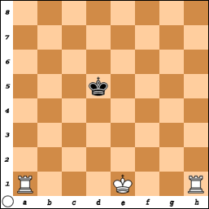
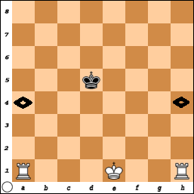
Starting from this position, White must plan which edge she would like to force the Black King towards.

She decides she wants to push the Black King back to the 8th Rank.
She has two possible moves that will limit and force the King to move.
White decides to move: R-a4.
(R-h4 is also fine, It iS CHOICE)!

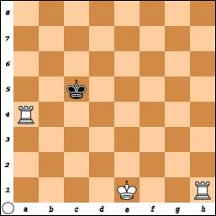
Black doesn’t want to move towards the 8th rank, he wants to stay in the center or on the 5th rank.

Thus, there are two choices: c5 or e5.
Black remembers the “rule” of:
‘Move Towards the Closest Rook’.

(Even though this is contrary to the idea of staying away from the edge)! So, K-c5.

Sometimes you must make hard choices!
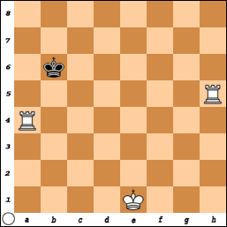
White continues to push the King back with the move:
Rook-h5 Check.

Black says, “Move towards the closest Rook”: King – b6.

This is where White can get in trouble if she just moves her Rook - a6 Check +.
The Black King can capture the piece that has put it in check!
(B.M.o.C. Kings can capture pieces!)

Moving the Rook on a4 to a5 is OK but still dangerous since moving the Rook on (h) could leave the Rook on (a) unprotected. WHY TAKE A CHANCE?

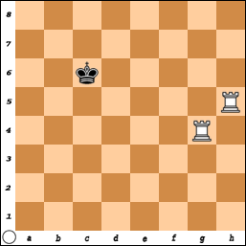
A better move is: Rook-g4! The Black King still cannot come forward because of the Rook on h5. He doesn’t want to move back to the 7th rank.
(The Rook can work from a distance!)
– so he stays in the 6th rank.

That leaves a6 or c6 – But the rule is …
Move towards the closest Rook – So, King - c6.

But, Black has lost this game in three moves and White will force Black to the 8th Rank.

1) Rook - g6 Check + King - d7
2) Rook - h7 Check + King - e8
3) Rook - h8 Checkmate #

It would not matter if the King moved to b7, c7 or d7 since he is too far away from the Rooks to hope White will make a mistake.

But since there is hope, the rule says “move towards the closest Rook”.
Make your opponent earn the Win – Don’t give up!

Even if you do make a mistake and lose a Rook,
It is possible to win with one Rook.

Place the Black King and two White Rooks on various squares on the board.

Practice this.......Practice this.......Practice this.
(You may remove the White King to do this exercise).

Even though this may seem like a silly exercise, it is very important. Many chess players 'think' they know how to solve this 'problem' only to fail when they are playing a game.

