The King must be along an Edge (either a Rank: 1 or 8 or File: a or h)

One Rook and a King
Like checkmate with two Rooks, to win with one Rook and a King:
1) The opponent must be against an edge.
2) Your King should be directly in front of his King. (One square away).
3) Your final move must be to check with the Rook on the edge.
(A special case does exist if the King is near the corner.)

Be careful to make sure, if the King is not in check, he has an escape square to move to.
You have learned the game is over when the King is in Checkmate.
To have checkmate, the King must be in check!

One saying often used is: “Check – It may be Mate!”

If the King is not in check, then it cannot be checkmate!

If the King cannot make a move, (and there are no other moves that can be made, and that will not put him in danger), then the game is over and it is a 'Stalemate' or the game is a tie.

Moving the Rook - b6 is not good (While the BOX is smaller), after the King moves to a7,
the Rook cannot move to a6 for the final check.

The Rook should stay at least one square away from the opponent’s King.
The Game-Of-Pawns
With Rooks
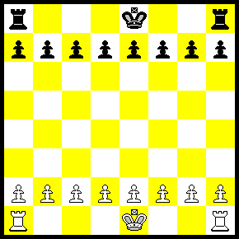

You have learned how to use the Rook and the King.

You can now play variations of the Pawn Game where each player has:
A) 1 Rook
B) 2 Rooks
C) Kings or No Kings

1) Play without the Kings and try to get a Pawn across the board.
or
2) Play with the Kings on the board and try to checkmate.

Remember, even though you start the game with all of your pieces, most of them are often captured during the game.

During Practice, you do not need to play entire games!

Finally, at the end you will have a few pieces left that are used to get the checkmate.

Learn to use the pieces you have!

a) White wins in 1 move  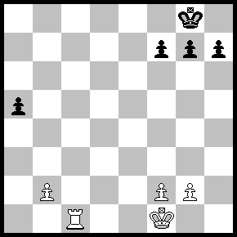 | b) White wins in 2 moves  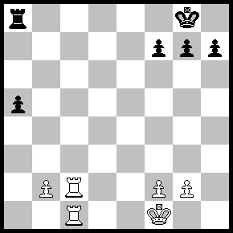 | c) Black wins in 1 move  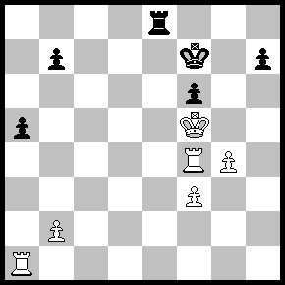
d) White wins in two moves  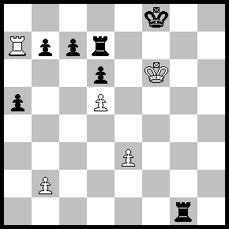 | e) Black’s turn but there are no good moves!  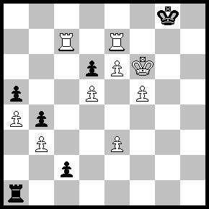 | f) White wins in two moves.  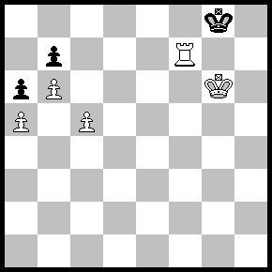

Answers:
a) Rook to c8 Mate # This is called a Back Row or Back Rank Mate.
b) Rook to c8 Check +, Rook takes Rook (R x R), Rook takes Rook Mate (R x R #)
c) Rook to e5 Mate # The Rook is protected by the Pawn on f6
d) Rook to a8 Check (R-a8+) Rook to c8 (R-c8), Rook takes Rook Mate (R x R #)
e) No matter what Black does, White has a Mate in one move!
(If King to f8: Rook - c8 Mate.... If Pawn - c8 = Q, then Rook to e8 Mate)
f) White mates Black in two moves with... Rook to f6. (or anywhere on the File f!)
The King must move to h8, then Rook to f8 Mate.
Three Moves: P-c6, P x P, P-b7, P-c5, P-b8 = Q – Mate #.
Rook x Pawn (B7) is not good since it allows Black freedom to move!

Any time a Pawn crosses the board and reaches the 8th rank for White or the 1st Rank for Black,
it can be exchanged for any piece (except for another King).

A Promoted Pawn cannot remain a Pawn. Therefore, it is possible to have 9 Queens or 10 Rooks, but more about this later.

