Chess has many special rules and it is a contest or battle. In any competition where there is a question about the rules, don’t believe what your opponent says!
They are the enemy.

Chess is a quiet game and no talking is required. You do not have to say check or checkmate, but if a person makes an illegal move such as failing to get out of check, it must be corrected and they must make another move that is legal.
Your opponent may know less (or have a misunderstanding) about the rules of chess than you do!

Do not let your opponent “bully” you with their “knowledge”!
Only believe what you know to be true or know where to go to find the truth.

In chess, the answers and rules are found in the USCF Official Rules of Chess. Remember, knowing the rules will not make you a great chess player;
it only allows you to play the game better.

You have to apply the rules and practice to play the game!

Learn the rules, try to master them, and always try to follow them.

In life, If you do not know something or are uncertain, read about it, think about it, ask someone about it! Seek knowledge and answers to your questions.

CASTLING
Since the King is the central piece in the game, it is important that he is protected. The King can often be protected “best” by being in the corner but, since he may only move one square at a time it is hard for him to move there. (Remember, the King is never removed from the board)

“Castling” is the only time when a player is allowed to move two men on the same turn: the King and the Rook.
Why isn’t it called “Rooking” since the rook is not called a “castle”?

One basic idea keep in mind is to castle as quickly as you can. There is a danger. If you wait too long, you may get into a position where you will be unable to take advantage of this special move.
If you castle too early, you have given your opponent a target!

You can castle only one time during the game and must follow the rules:
Rules for Castling
1) The King and the Rook must be on their original squares.
2) Neither piece may have been moved during the game.
Keeping notation is a way to 'remember' if the King or Rook has moved.
3) The King cannot castle to get out of check.
You must seek protection BEFORE you are in danger.
4) The King cannot castle if he will pass through a square being attacked.
Since a King cannot place himself in check, he may not castle through (over) a square that would place him in check.
5) There can be no other pieces between the King and the Rook.

How to Castle

The King moves over two squares (toward the Rook),
and the Rook jumps over the King and lands beside him.

On the KING side, or castling 'short', the King moves two squares to the right and lands on the Knight square (g file) and the Rook lands on the Bishop (f file) square.

O - O is chess notation for King Side Castling.

On the QUEEN side, or castling 'long', the King moves two squares to the left and lands on the Bishop square (c file) and the Rook jumps over and lands on the Queen square (d file).

O - O - O is the notation for Queen Side Castling.

You should move the King first. Since a King can normally only move one square, moving two squares indicates you are castling.

Remember the 'TOUCH MOVE' rule? It says if you touch a piece, your opponent may make you move it? Thus, if you touch the Rook first, your opponent might try to claim you cannot castle since you have moved your Rook.

Be careful! The American rule does allow for either the Rook or the King to be moved first, but the International Rule requires the King to be moved first.
Be safe and move the King first.

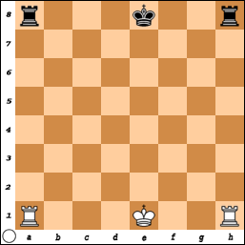
Some players use “two hands” to crisscross and move both pieces at once but this is not really necessary. .
Here is a board without any of the other pieces.
(It would be unlikely this position would ever occur).

The Kings and Rooks are in their original position (and have never moved).

Even if the Rook and King are in their original position,
if either piece has been moved,
you may not Castle.

Black has Castled Short on the King Side  and White has Castled Long  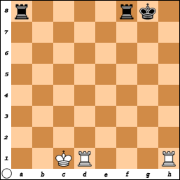  on the Queen Side. | White has Castled Short on the King side  and  Black has Castled Long on the Queen Side.  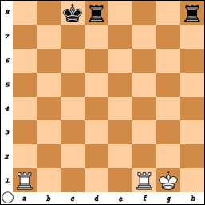

The king always moves two squares,
and the Rook jumps over it and lands by his side.
Neither White nor Black has moved their King or Rook, so both sides could castle if the other rules are met.

When thinking about moves, remember the three questions to ask:
1) What is under attack right now?
2) What is about to be attacked?
3) What can I attack (or, what can I do to avoid from being attacked)?

What is the Best Move for White?
a) O-O-O ????
Why would this be a Very Very Very bad move?
Black would play Q-b1 ++ Checkmate.

b) How about N x Q? or P x Q? - Either move will win the Queen!
But, what would Black do next? (Don’t take the poison bait!)
Black would just play: R-h1 # Checkmate.

c) Is N x N+ a good move?
This does put the Black King in Check – but, Is the Game Over?
No... B x N,
and White is lucky that R-c8 is still Checkmate.
But why waste time....

d) White plays R-c8 # Checkmate and the game is over.
What if it is Black's turn?
a) Save the Queen!
Good thought, but is there a winning move?
Question #3) What can I attack? - Is it strong enough?

b) Castle: 0-0
It cannot be done. The Bishop is covering a square the King would pass through. Too bad, the King waited too long to castle and now it is too late.

c) R-h1 # checkmate wins the game.

ALWAYS LOOK FOR THE WINNING MOVE.

REMEMBER THE OBJECTIVE.

THE GAME IS NOT OVER UNTIL THE LAST MOVE IS MADE.

You win the game with Checkmate!

