Another Rule and Power for Pawns

For being the smallest piece, the Pawn has a lot of special rules to follow.

The rules of chess we have today are not the same rules that were used years ago. Man has changed the rules of the game over time. However, the rules and Laws of science and nature are unchanging and constant.

At one time, the Pawns could only move one square at a time.
The current rules allows for a pawn to move 1 or 2 squares on its first move.

Because of the rule change that allowed a Pawn to move two squares on its first move, the En Passant rule was also created.

People are so often in a hurry to get somewhere or do something. Pushing the Pawn two squares is a fast way to start the Pawn on its journey across the board. When a Pawn could only move one square at a time, Pawns had to get near each other at some point in their trip across the board.

In this example, the White Pawn has moved to the c5 square. If Black was to move either his 'b' or 'd' Pawn the optional two squares, White would NOT be able to capture it since Pawns only move forward and capture diagonally.

However, the En Passant - or In Passing rule does allow for the Pawn to be captured. It doesn't happen often, but it is a good rule to know.

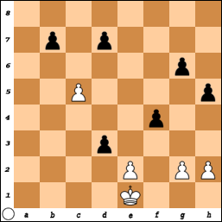
Everyday we are passing people and people are passing us. We tend to get so busy in our own little world that we miss what is really going on. Many times, we are given the chance to touch someone in some way and we do not do it. It may be nothing more than a simple smile at the person in line, or to the driver in the car that just cut in front of you, or maybe to a family member, friend, co-worker, or someone you do not even know yet.

It is up to you to use every opportunity to be kind to others. You cannot change how the other person behaves, but you can change how you behave toward other people. It also does not matter how you compare to other people. Do what is right!
You never know who you might run into: W. I. N.

The En Passant Rule:
This rule is a little tricky and many chess players do not understand how it works. 'En Passant' is a French word that means 'in passing'.
In chess notation it is written P x P ep. or for example c x d ep.

En Passant only works with Pawns.

THE RULE SAYS:
If a player moves a Pawn two squares, could it have been captured if it had only been moved 1 square?

If the answer is 'YES', and you want to capture the Pawn, you must do so on you very next turn.

YOU MUST ACT QUICKLY AND TAKE ADVANTAGE OF
ANY OPPORTUNITY THAT IS PRESENTED.

If you COULD NOT have captured the Pawn if it had advanced 1 square, then the En Passant rule cannot be used.

It only works when the Pawn moves from its original square
And was moved 2 squares.

In chess notation:
White can only capture a Black Pawn if White has a pawn on the 5th rank and Black pushes a Pawn two squares.

Black can only capture a White pawn if the Black Pawn is on the 4thrank and White pushes a Pawn two squares.

Black is really excited about this game.

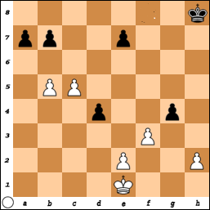
He feels he should be able to push his ‘a’ Pawn down the board. If the King tries to go after it, He has Pawns on ‘d’ and ‘g’. White would not be able to stop them all from moving down.

The only Pawns that can be captured with En Passant are those that move two squares from their original starting position.

The only Pawns of Black still has on their original squares are the ‘a’ and ‘e’ Pawns.

The only Pawns of White that Black could capture are the ‘e’ and ‘h’ Pawns.
If White was to move the ‘f’ Pawn one square, it would look like Black could capture it, but the rule says it must have moved two squares.
This is another reason for recording your moves.

Black plays: P-a5 and White captures PxP ep. (b5 x a5 ep).
(Black is really surprised because he is unfamiliar with this rule!)

The White Pawn is now on a6. Black really must recapture (b7 x a6) but then the White c5 Pawn marches in for a promotion with three moves.

If Black does not recapture with: b7 x a6,
then White advances to a7 and then a8.

